<https://www.redfin.com/city/16904/CA/San-Diego/real-estate/agents>

<https://globella.com/>

A The Way Home Selling in South Calgary Should Be (also NorthWest, Central, Inner City, West)

B Work with a home marketing expert exclusively on your side AND sell your Calgary home for top dollar.

C Free Selling Consultation and Market Value Analysis

D No tricks, just friendly advice

New Section (full width banner showcasing overview of 5 star reviews similar style to this (but with the 5 star google review:

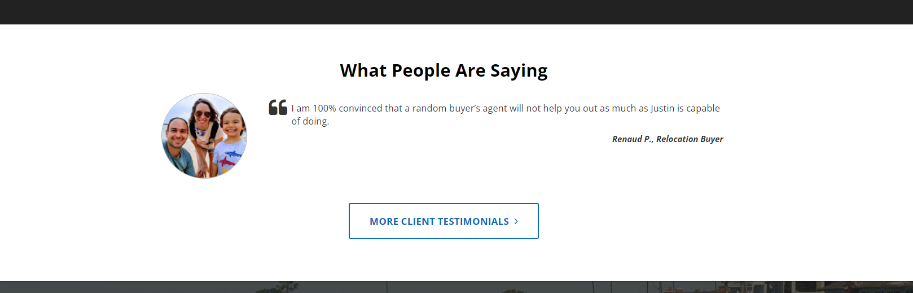

New Section

Sell with a Top Rated Re/Max Agent in Calgary

The Group at Re/Max First agents sell home for $XXXXX more on average.



New Section Call to Action

Similar to this but change the keys on the end to a sold sticker

(I’ll edit the text after to reflect selling vs buying process)

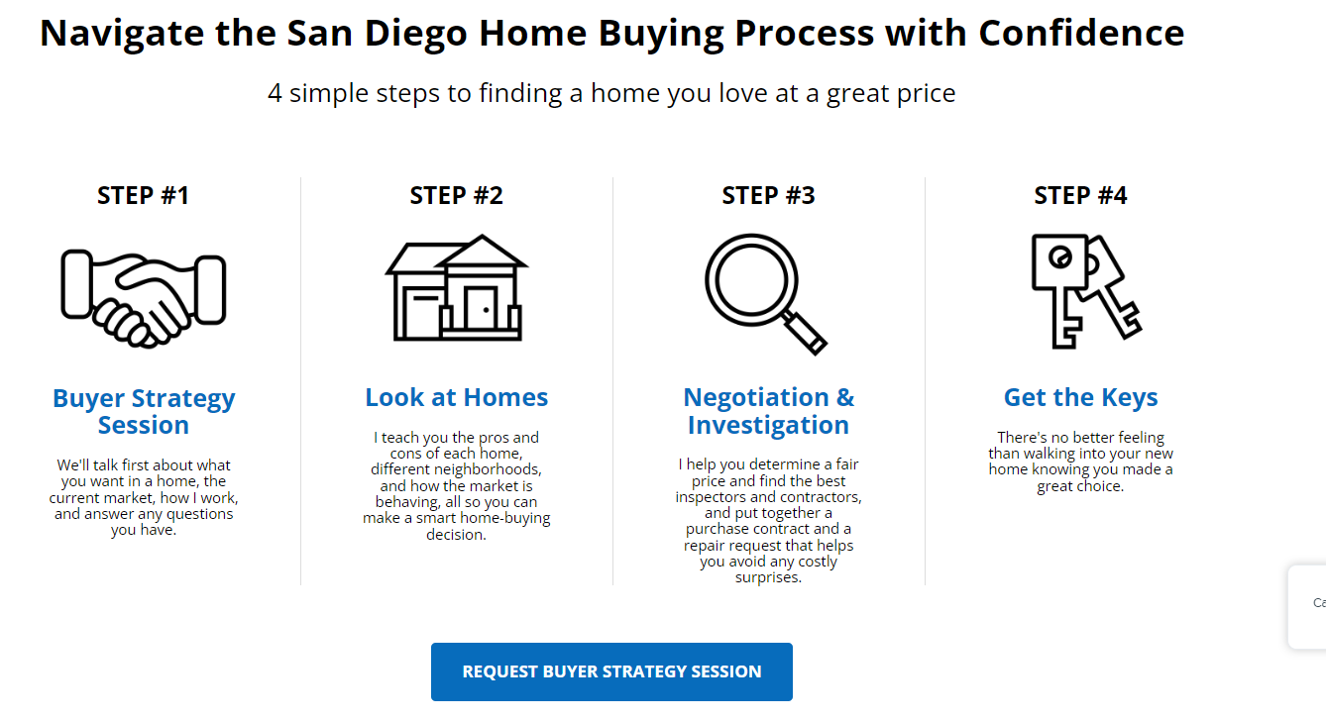

New Section (full width no images)

H1 Why you need a top real estate agent in Calgary

To sell your home and achieve your overall real estate goals in the South side of Calgary, you need a top Calgary agent with the best reviews. Top agents like these bring the experience of XXXX years in business and 10 times the average agents number of homes sold. While average agents will tell you what you want to hear, an experienced and professional agent will advise you on what you need to know. They will sell your home faster, and for more money, and will not set you up for a slew of price reductions. They will guide and coach you with open, honest advice based on facts and current market data and knowledge. And, most importantly, they will respect your right to make the decisions.

This section will have 3 boxes across the width and link to areas further down.

1. The best home marketing

We’re proud to say that our property promotion has won several international marketing awards. Better Homes deserve Better Marketing, and Better marketing, promotes better.

1. Free and unbiased Advice

Our initial consultation and your property Market evaluation is 100% free, with no catch. We earn your business though our initial consult, so you get the best advice.

1. Save time and hassle

It takes just two minutes to match you with the best real estate agents for you and your location. The best agent will contact you and guide you through the process.

New Section (2 sided like you already mocked up)

Find the best agent or REALTOR® for your favorite South Calgary neighborhood

Research transactions in the last 5 years mapped to your neighbourhood. Homes bought and sold in Calgary, are mapped and listed beside. Our top agents are frequently doing deals in Auburn Bay, Copperfield, Cranston, Legacy, Mahogany, Mckenzie Towne, Mckenzie Lake, Silverado and Walden.

Show embed of the live google mapped transactions that you did but centered on the appropriate area.

New Section

Frequently Asked Questions

What does a top real estate agent do?

Top real estate agents have more local expertise, prepare in-depth market analyses, have superior property marketing, and have high traffic websites that most agents can’t compete with. They know South Calgary like the back of their hand and use their market knowledge to sell your home faster than the average agent and for money.

What should you look for when interviewing a real estate agent in Calgary?

When you sell a house, your REALTOR® becomes your partner, advisor, and support system. It’s crucial to partner with an agent you like and trust. Make sure you’re hiring an agent who can answer all of your questions with confidence, and who tells you the things you need to do to get to your goals. Discuss the agent’s business and find out how well they know the area, how much business they do, and ask for samples of previous marketing. Ask questions that signal experience, expertise in the area, and honesty in their communication. Listing a property takes a lot of work, so you need a topo agent who’s got a strategy and system for preparation, pricing, and advertising and who will work with you throughout.

Is it important to hire the best real estate agent in Calgary?

Data shows that the top 5% of listing agents sell more homes than the average real estate agent. A great agent makes a difference in a home purchase as well. Whether you’re in the market to find your dream home or sell your property at the highest price, the right agent will give you the best chance. Connect with a top real estate agent if you’re buying or selling a home in South Calgary soon.

When is the right time to hire a real estate agent in Calgary?

Its best to call an agent to sell your home within three to six months prior to your list date. When you start talking to an agent several months before wanting to sell, it leaves enough time to find the best agent, be advised of key preparations, and market your home for all its worth, all of which are essential elements in selling for top dollar. Seasonal and cyclical trends in the market can also effect when you want to list, and the typical “list in the spring market” mentality is not exactly correct. The Group recommends that you talk to one of our REALTORS® as soon as you're thinking of listing your home for sale. Generally speaking, that's anywhere from 3 to 6 months prior to your desired move date.

What is the average real estate agent commission for agents in San Diego?

While individual real estate agent commissions do vary, most real estate agents in Calgary work for 7% on the first $100,000 and 3% on the balance of the home sale price. This will typically be split down the middle to be shared between the buyers agent who brings in their buyer clients, and the listing or marketing agent who markets and represents the seller and the listed property. Home sellers in Calgary are fortunate as the real estate fees for selling here are among the lowest in North America, with the typical being a flat 5% and many areas having land transfer taxes on top of that.